R :
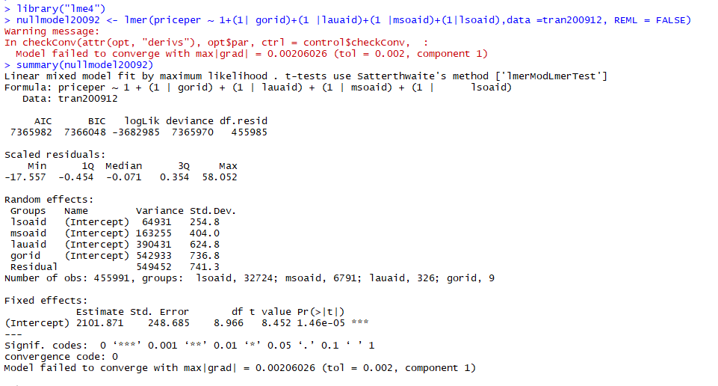
R:
library("R2MLwiN")
options(MLwiN_path = "C:/Program Files/MLwiN v3.03/")
F1 <- priceper ~ 1+(1| gorid)+(1 |lauaid)+(1 |msoaid)+(1|lsoaid)+(1|tran2009id)
VarCompModel <- runMLwiN(Formula = F1, data =tran200912)
summary(VarCompModel)
